Progress & Delivery report

For: Client

Function:

By: First / Last name

Title:

**Campaign Performance & Market Response Overview**

At the start of this assignment, our shared objective was clear: to identify and engage high-calibre professionals equipped to thrive within **[Client Company Name]**'s [insert essence of the role—e.g. “scaling commercial operations across EMEA,” “driving adoption of a disruptive diagnostic platform,” etc.].

With this goal in mind, QTC Recruitment launched a targeted search campaign, rooted in our benchmark-driven methodology and powered by our proprietary Life Sciences talent network.

To maximise early traction and insight, we activated a structured, multi-channel outreach strategy across three core pillars:

* **Targeted identification** through QTC’s Life Sciences network, drawing from curated warmlists and behavioural data across 300,000+ profiles.
* **Precision outreach** via LinkedIn Recruiter and personalised, signal-based engagement to trusted warm contacts.
* **Public campaign activation** via QTC’s platform, LinkedIn job boards, and relevant industry communities (e.g. MedTech, Diagnostics, Biotech) to generate qualified inbound traffic.

This first phase wasn’t solely focused on volume. It was designed to generate real-time intelligence testing salary benchmarks, gauging brand perception, and understanding candidate motivations and objections. These insights now actively inform our evolving positioning and final shortlist construction.

The next section outlines key metrics from the campaign to date and introduces the most aligned profiles based on traction, fit, and performance potential.

**Our Search Philosophy: Built on Process, Designed for Precision**

Recruitment is often seen as a people business. At QTC, it's also a process business and that process is what allows us to consistently deliver exceptional candidates when it matters most.

Our methodology is the result of over 20 years of Life Sciences recruitment experience, refined and structured using Lean Six Sigma principles. This gives every search a predictable rhythm, continuous improvement cycles, and an underlying commitment to quality and efficiency.

The foundation is our proprietary 10-step recruitment framework, built to eliminate friction and add structure to every phase from intake to onboarding and beyond.

**What that means for your organisation:**

* **Structured job intake and benchmarking** to clarify expectations and calibrate fit.
* **Precision targeting** through a blend of proprietary talent pools, LinkedIn campaigns, and referral-driven outreach.
* **Market feedback loops** built in from day one, allowing us to adapt quickly based on response rates, message testing, and candidate sentiment.
* **In-depth shortlisting and deep dives** into technical fit, leadership traits, motivational drivers, and long-term alignment.

**Key metrics around position based on Linked-In Insights (we need to come up with better visuals but I believe you get the point).**

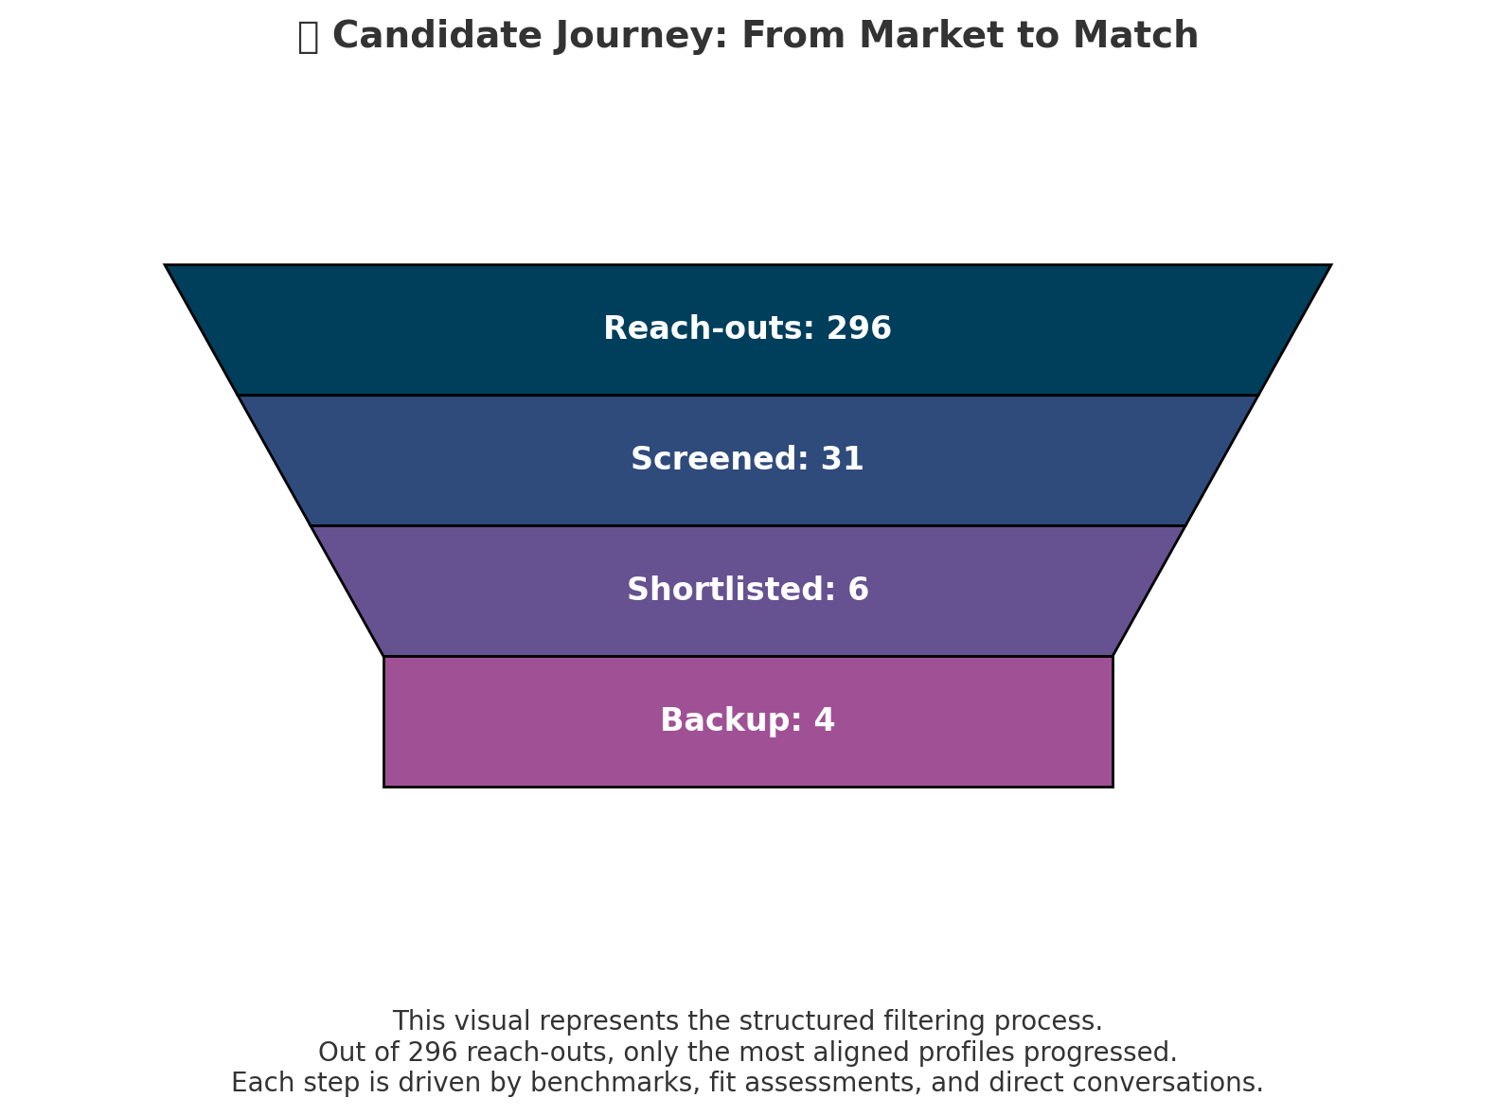

**Sourcing Performance Summary**

|  |  |  |
| --- | --- | --- |
| **Metric** | **Value** | **Notes** |
| Job post live date | [DD-MM-YYYY] | Activated on QTC & LinkedIn |
| Days role was live | [X days] | Total campaign duration |
| LinkedIn job views | [X,XXX] | Organic reach and interest |
| Total reach-outs (inmail/direct) | 296 | Targeted outreach via QTC network & LinkedIn |
| Response rate (%) | [X%] | Candidate replies vs. reach-outs |
| LinkedIn InMails sent | [XXX] | Precision outreach |
| Avg. time to shortlist | [X days] | From go-live to delivery |

**Consultant Interpretation**

* **Engagement vs. Effort**  
  The 296 direct outreach attempts reflect a disciplined, signal-driven effort. A strong response rate (X%) suggests the market is **receptive to the opportunity**, and our message is landing well with the right profiles.
* **Screening Efficiency**  
  From 31 conversations, 6 candidates progressed to the shortlist. This **CV-to-shortlist ratio** demonstrates **targeting precision** and **screening discipline**. Our goal is always to deliver fewer—but better profiles that align not just technically, but strategically and culturally.
* **Market Positioning Insight**  
  Disqualification data particularly around salary or role perception helps refine your employer value proposition. If motivations or salary misalignment surfaced, it likely reflects either **market positioning gaps** or evolving expectations in this talent segment.
* **Optional Talent Pools**  
  The 4 backup candidates show that while the market is selective, there is **depth beyond the shortlist**. These profiles can be reactivated quickly if scope shifts, timing changes, or if you wish to explore a broader candidate comparison.
* **Process Velocity**  
  An average time-to-shortlist of [X days] reaffirms our **structured process and proactive execution**—keeping momentum high and the window for candidate engagement tight.

**Shortlist presentation:**

{% for candidate in message.content["Shortlist presentation"] %}

{{ candidate.Candidate }}: Candidate Information

• **Name**: {{ candidate.Name }}

• **Location**: {{ candidate.Location }}

• **Salary expectation**: {{ candidate["Salary expectation"] }}

**Education**

{% for edu in candidate.Education %}

• {{ edu }}

{% endfor %}

**Professional Background**

{% for role in candidate["Professional Background"] %}

• {{ role }}

{% endfor %}

**Profile Match (Client-Specific)**

{% for match in candidate["Profile Match (Client-Specific)"] %}

• {{ match }}

{% endfor %}

**Practical Information**

{% for info in candidate["Practical Information"] %}

• {{ info }}

{% endfor %}

{% endfor %}

**Final Recommendation:**

{{ message.content["Final Recommendation"] }}